Intent, Implementation and Impact of the Maths Curriculum at Charlton- on-Otmoor
Introduction:
This policy has been developed in order to ensure that the teaching of mathematics contribute to the school fulfilling its mission statement:

‘Aspire and Grow Together’

Underpinning the maths curriculum at Charlton are our three strategic aims:
Having high aspirations for every pupil
Developing pupils with the skills required for the 21st century
Enabling pupils to become global citizens

As is clearly stated in The National Curriculum, we believe at Charlton that Mathematics is a creative and highly inter-connected discipline that has been developed over centuries, providing the solution to some of history’s most intriguing problems. It is essential to everyday life, critical to science, technology and engineering, and necessary for financial literacy and most forms of employment. A high-quality mathematics education at Charlton provides a foundation for understanding the world, the ability to reason mathematically, an appreciation of the beauty and power of mathematics, and a sense of enjoyment and curiosity about the subject.

The maths policy outlines the framework within which all staff teach mathematics at Charlton-on-Otmoor CE Primary School and gives guidance on planning, teaching and assessment. The policy outlines clearly how the school intends to meet the needs of all mathematics learners within mixed-age classes ensuring that every child achieves their full potential.
Aligned with the aims of the National Curriculum we want our pupils to:
- Become fluent in the fundamentals of mathematics through varied and frequent practice with complexity increasing over time.
- Develop conceptual understanding and ability to recall and apply knowledge rapidly and accurately.
- Reason mathematically; follow a line of enquiry, conjecture relationships and generalisations.
- Develop an argument, justification and proof by using mathematical language.
- Problem-solve by applying knowledge to a variety of routine and non-routine problems. Breaking down problems into simpler steps and persevering in answering.
The National Curriculum sets out year-by-year programmes of study for key stages 1 and 2. This ensures continuity and progression in the teaching of mathematics.
The EYFS Statutory Framework 2021 sets standards for the learning, development and care of children from birth to five years old and supports an integrated approach to early learning. This is supported by the ‘Development matters’ non statutory guidance.
The EYFS Statutory Framework in relation to mathematics aims for our pupils to:
- count confidently,
- develop a deep understanding of the numbers to 10, the relationships between them and the patterns within those numbers
• develop their spatial reasoning skills across all areas of mathematics including shape, space and measures
• develop positive attitudes and interests in mathematics, look for patterns and relationships, spot connections, ‘have a go’, talk to adults and peers about what they notice and not be afraid to make mistakes
The intent of mathematics in our school is to develop:
- Students who have a positive attitude towards maths and an awareness of the relevance of mathematics in the real world
- Pupils who are fluent in the fundamentals of mathematics
- Pupils able to problem solve, to reason, to think logically and to work systematically and accurately
- Children who have the initiative and motivation to work both independently and in cooperation with others
- A confident communication of maths where pupils ask and answer questions, openly share work and learn from mistakes
- A curriculum which provides opportunities for cross curricular learning opportunities
Implementation will be achieved through the following:
- Careful planning and preparation
Long term planning
Charlton uses the National Curriculum for Mathematics 2014, Development Matters and the Early Learning Goals as stated in the Statutory Framework 2021 (Number, Numerical patterns) provide the long term planning for mathematics taught in the school. We also use the White Rose progression documents to ensure that the age appropriate skills are being covered across the year.
Medium term planning
Years 1-6 (Pathfinders, Adventurers and Explorers) use the White Rose Maths Hub mixed-age schemes of learning as their medium term planning documents.
These schemes provide teachers with exemplification for maths objectives and are broken down into fluency, reasoning and problem-solving. They support a mastery approach to teaching and learning and have number at their heart. They ensure teachers stay in the required key stage and support the ideal of depth before breadth. They support pupils working together as a whole class and provide plenty of time to build reasoning and problem solving elements into the curriculum.
Below is an example of the year 3 and 4 class mixed-age overview:
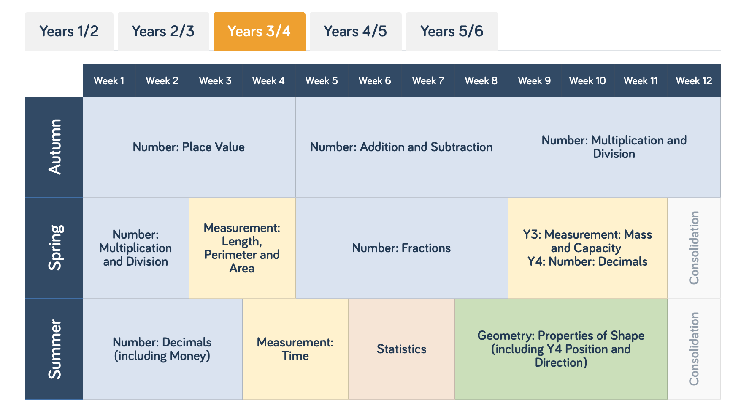

This supports teachers with the progression and sequence of learning within a block of learning.
How do teachers use the White Rose planning:
  - Teachers begin each unit of learning by identifying the common and discrete content. This can be found within the White Rose schemes of learning.
  - The units are divided into different themes.
  - Within the themes teachers will identify the learning intention ensuring that the National Curriculum aims for both year groups are being met.
  - Finally teachers will plan in opportunities for maths talk, fluency, reasoning and problem-solving.
Planning is monitored at intervals by the mathematics subject leader and headteacher.
What does Mathematics look like in nursery at Charlton:
Nursery children follow the similar themes taught in Early Years following Development Matters 3 to 4 years. Teachers within the nursery ensure the children learn through a mixture of adult led activities and child initiated activities both inside and outside of the classroom. A Mathematics input happens daily through an integrated approach.
How do teachers plan in reception?
Teachers follow the White Rose long term planning overview for Reception which can be seen below:
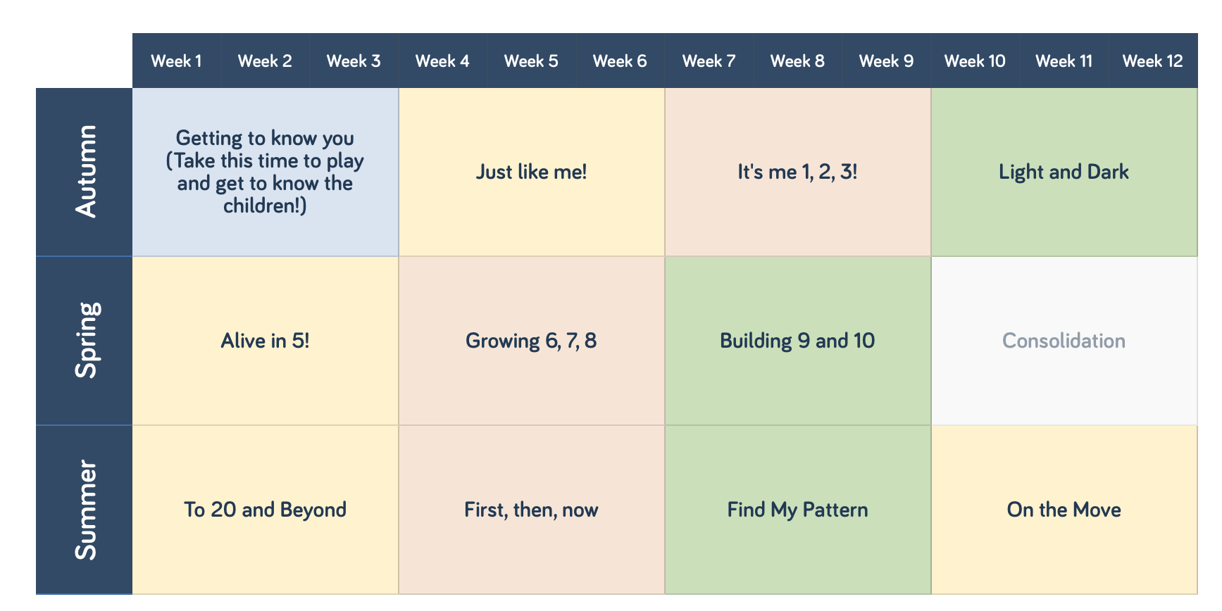
Each unit is known as a ‘phase of learning’. Teachers take the key learning progression from each unit and add this onto their weekly planning grid.
All classes have a daily mathematics lesson each morning.
Teachers of the EYFS ensure the children learn through a mixture of adult led activities and child initiated activities both inside and outside of the classroom. Mathematics is taught daily through an integrated approach.
Special educational needs & disabilities (SEND)
Daily mathematics lessons are inclusive to all pupils with special educational needs and disabilities. Within the daily mathematics lesson teachers have a responsibility to not only provide differentiated learning opportunities to support children with SEND but also activities that provide sufficient challenge for children who are high achievers. It is the teachers’ responsibility to ensure that all children are challenged at a level appropriate to their ability.
Teachers will need to plan in how to use their teaching assistant to best support the children within the class. Where required, children’s IEP’s incorporate suitable objectives from the National Curriculum for Mathematics or development Matters and teachers keep these in mind when planning work. These targets may be worked upon within the lesson as well as on a 1:1 basis. Maths focused intervention in school helps children with gaps in their learning and mathematical understanding. These are delivered by trained support staff and overseen by the SENCO and/or the class teacher.
Equal Opportunities
Positive attitudes towards mathematics are encouraged, so that all children, regardless of race, gender, ability or special needs, including those for whom English is a second language, develop an enjoyment and confidence with mathematics.
Each unit of work will entail a range of concrete, pictorial and abstract learning opportunities to engage and inspire the pupils. Differentiated questions will also be used in lessons to help children with planned support from Teaching Assistants and lots of opportunities for maths talk.
- Our aims will be achieved by a consistent and high quality approach to mathematics teaching
Charlton expectations:
This will be happening within maths lesson in KS1 & KS2
  - The learning intention to be on display and shared
  - clear instructions
  - teacher modelling learning in line with the school calculation policy
  - an up to date learning wall with appropriate vocabulary on view to promote independent learning
  - teachers giving accurate and well-paced explanations;
  - misconceptions to be used as a teaching point and to be developed
  - recorded work in books to be evidence on most days in KS1 and KS2
  - Work recorded in books will be marked
This will be happening within every scheme of learning:
  - Opportunities for maths talk
  - Fluency within lessons
  - Evidence of problem-solving and reasoning
  - Teachers to provide opportunities for children to develop their understanding and learning through using a CPA approach (concrete, pictorial and abstract).
  - Evidence of progression in learning through children’s work in books
As a school, we recognise the importance of including cross-curricular opportunities to contextualise the learning.
Pupils’ recording in books (Years 1-6)
Presentation is extremely important and we expect children at Charlton to take pride in their work. Formal written methods are encouraged with the teacher modelling the correct procedure to use. Practical maths is extremely important and we expect to see evidence of this alongside the formal written methods. Children’s books will be show evidence of the learning journey within each unit.
Marking
Marking of children’s work is essential to ensure they make progress. All recorded work in books will be marked. Work is marked against the learning intention. Children are encouraged and given time to read teachers’ comments and make corrections or improvements. Responses to marking are made as close to the work as possible, ideally at the start of the next lesson. Live marking is encouraged to provide immediate feedback to pupils within lessons. Pupil marking takes place using a green pen whereas teachers mark using purple.
Assessment
Assessment is an integral part of teaching and learning and is a continuous process. Teachers make assessments of children daily through;
- Marking of work
- Analysing errors and picking up on misconceptions
- Asking questions and listening to answers
- Facilitating and listening to discussions
- Making observations
These ongoing assessments inform future planning and teaching. Lessons are adapted readily and short term planning evaluated in light of these assessments.
Children in the FSU are continually assessed in maths through small group or 1:1 tasks set by the adult (adult focused tasks). Children are also observed demonstrating their mathematical learning in their play through carefully planned activities linked to current and previous learning. These observations and assessments are recorded on the Tapestry Learning Journal app, on assessment sheets or work that is collected and kept in their Learning Journey folders.
Assessment timetable 2021-22:
 | Early Years | Year 1 and 2 | Year 3 and 4 | Year 5 and 6
Autumn Term | Baseline assessments and ongoing assessments | Year 2 SATs Papers | NFER  Assessments | NFER  Assessments
Spring Term | Ongoing assessments | NFER Assessments (Year One)  SATs Year 2 | NFER  Assessments | NFER Assessments
Summer Term | Ongoing assessments and End of year profile completed | KS1 SATs (2)  NFER Assessments (1) | Year 4 Multiplication Tests  NFER Assessments | KS2 SATs (6)  NFER Assessments (5)
 |  | Teachers in KS1 and KS2 may decide to use the White Rose Block Assessments to support their teaching and assessment in addition to the end of term assessments.
These assessments are used alongside judgements made from class work to support teachers in making an assessment for each child which in line with the assessment policy they enter onto Insight Tracking. Each term, teachers will decide if children are working below, just below, at or above age expectations.
Pupil Progress meetings are timetabled each term for all classes. Progress of pupils is discussed and appropriate intervention considered and put in place where appropriate.
Resources
Each class has a stock of core resources that are age appropriate. Additional mathematical equipment and resources are stored centrally in the resources room.
Times Table Rockstars
Times Table Rockstars is a fully interactive online mathematics learning tool for children and is used by teachers to support the teaching of times tables in mathematics learning both in class and at home.
Homework
Children are set homework in line with the homework policy.
- Our aims will be achieved through effective Maths leadership:
Role of the Maths Subject Leader
- To lead and inspire in the development of maths throughout the school.
- To monitor the planning, teaching and learning of mathematics throughout the school.
- To support the headteacher in raising standards across the school.
- To provide teachers with support in the teaching of mathematics.
- To provide staff with CPD opportunities in relation to maths within the confines of the budget and the School Improvement Plan
- To monitor and maintain high quality resources.
- To track progress of pupils
- To keep up to date with new developments in the area of mathematics

The Impact of our Maths policy:

- Pupils at Charlton will achieve high standards in mathematics in terms of their attainment and in making progress from their starting point
- Students have a positive attitudes towards maths and an awareness of the relevance of mathematics in the real world
- Pupils are fluent in the fundamentals of mathematics
- Pupils are able to problem solve, to reason, to think logically and to work systematically and accurately
- Children have the initiative and motivation to work both independently and in cooperation with others
- There is a confident communication of maths where pupils ask and answer questions, openly share work and learn from mistakes

Policy last reviewed – September 2022
Next review – September 2023
Subject Leader – Emily Holmes/Ross Griffin

